Part IV
System Analysis and Design

Section 1: Database Design & Data Modeling
Section 2: UI/UX Design & Prototyping
Section 3: Dashboard Navigation Guide

4. System Analysis & Design

4.1 Database Design & Data Modeling

Data Schema Diagram
The analytical data model in Power BI is designed using a Fact Constellation structure with selective Snowflaking, where multiple fact tables share common dimension tables. The diagram represents the Power BI logical data schema, as opposed to a traditional Entity–Relationship Diagram typically used in database engineering. This design approach supports model purity, consistent granularity, and efficient filtering performance across analytical workloads.

A. Model Structure and Fact Separation:
- Separation of Fact Tables: To maintain semantic clarity and ensure accurate analytical calculations, the model separates operational metrics into two distinct fact tables based on their granularity and business meaning:
- fLineProductivity: Contains positive time-related metrics, such as total productivity or operating time.
- fLineDowntime: Contains negative time-related metrics, including total downtime and detailed downtime events.
- Justification: This separation enforces Measure Purity, prevents metric duplication, and ensures reliable computation of composite KPIs such as Net Operating Time by enabling simple additive/subtractive logic (e.g., Production Time − Downtime). Separating the facts also preserves the integrity of granular event-level records.
- Shared Dimensions: Shared dimension tables - including dProducts, dDowntimeFactors, and dOperators - provide a unified filtering context across both fact tables. These dimensions support consistent slicers, model navigation, and cross-table analysis within Power BI, while reducing redundancy through centralized reference data.

B. Strategic Dimension Creation: The dOperators Table:
- Normalization: The dOperators dimension was created by extracting operator - related descriptive attributes from the fact table. This follows standard normalization principles, resulting in a cleaner structure, reduced redundancy, and improved model maintainability.
- Performance: Storing textual and descriptive attributes in a separate dimension table linked via a numeric key (OperatorID) enhances query performance by improving columnar compression, reducing memory usage, and increasing filtering efficiency within Power BI.

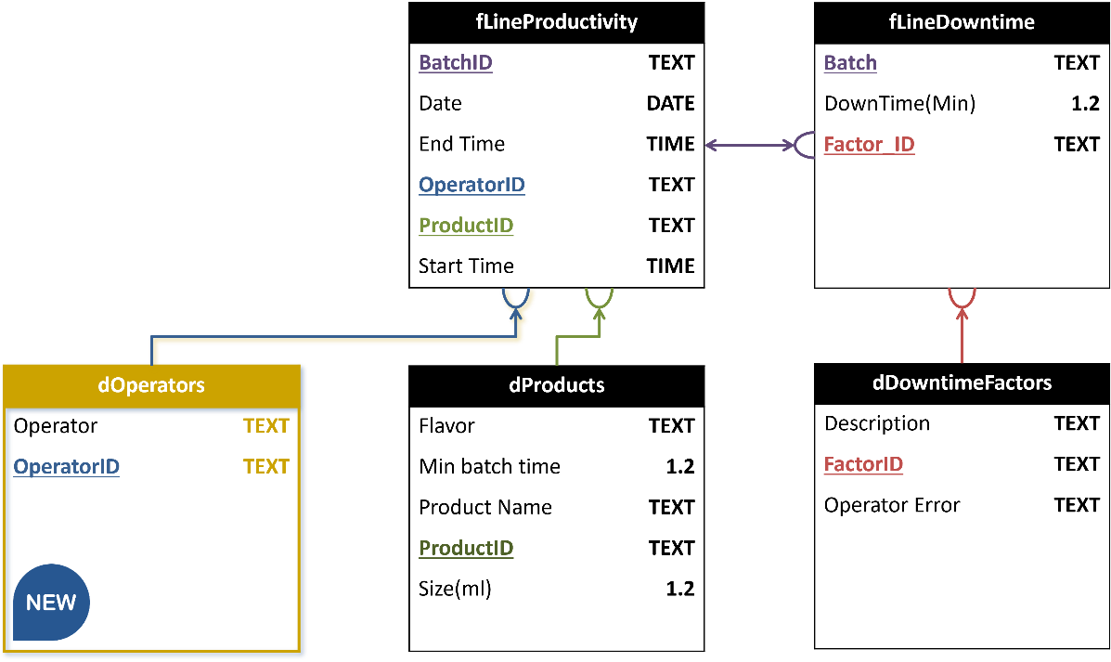
Figure 4-2-1 Snowflake Schema

4.2 UI/UX Design & Prototyping
This section outlines the UI/UX design system, layout strategy, interaction flow, and visual identity used in the Dashboard. The purpose is to ensure a consistent, scalable, and user‑centered design across all dashboard pages.

4.4.0 Design Tools & Methodology
A standardized UI/UX workflow was followed throughout the dashboard development process.
Initial wireframes were created to validate layout logic and user flow. These structures were then translated into high-fidelity visual mockups using Figma, applying the approved color palette, typography, and interaction guidelines.
The finalized layouts were subsequently implemented in Microsoft Power BI, ensuring full alignment between design intent and functional execution.
Tools Used:
- Figma: Visual design & component styling
- Draw.io: Wireframes & structural mapping
- Power BI: Final dashboards & interactive implementation

4.4.1 Wireframes & Mockups
The following wireframe descriptions represent the structure of the dashboard pages. Actual visuals are implemented in Power BI.
- Home Page: Title, introduction, shortcuts, and navigation.
- Production Overview: Batch performance, productivity trends.
- Downtime Analysis: Factors breakdown, top contributors, trend charts.
- Operators Performance: Operator error frequency, benchmark comparison.
- Drill-through Pages: Detailed view for a selected product or operator.
Home
Downtime Analysis
Production Overview
Operators Performance
Drill-through: Product
Drill-through: Operator

Figure 4-4-1-1 Dashboard Navigation Map

Column Chart
[Fastest Products]
KPI Cards
Bar Chart
[Most Frequent Causes]
Bart Chart
[Downtime by Day Shift]
Navigation
Filter
Page Title
Column Chart
[Product Downtime]
Drill-through Button

Figure 4-4-1-2 “Downtime Analysis” Page Wireframe

Bar Chart
[Operators Comparison]
Product Name
Gauge Chart
[Efficiency Rate]
Trend Line
[Performance Over Batches]
Page Title
Donut
[Batches Contribution]
Back Button
Donut
[Downtime Causes]
Donut
[Operator Contribution]
Bar Chart
[Downtime Factors]

Figure 4-4-1-2 “Product Details” Page Wireframe

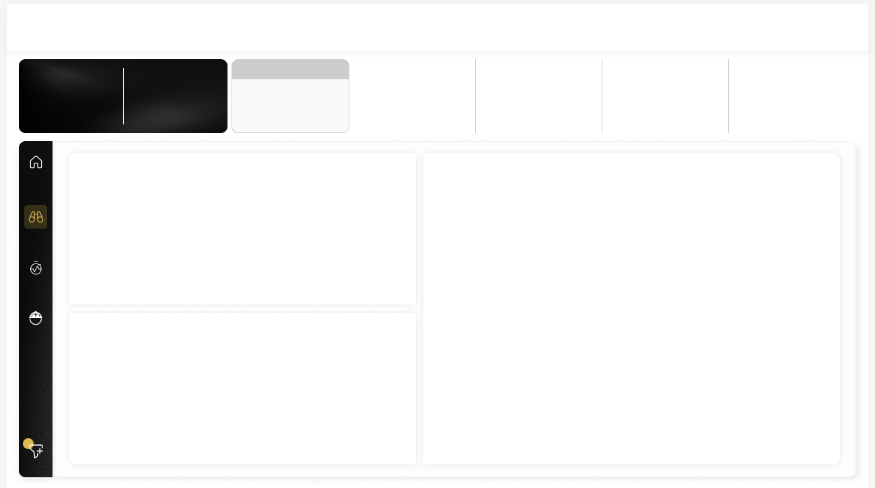
Heatmap
KPI Cards
Scatter Plot
Bar Chart
Page Title
Navigation Buttons
Filter Button

Figure 4-4-1-3 “Production Overview” Page Figma Mockup
Figure 4-4-1-4 “Production Overview” Final Page

4.4.2 UI/UX Guidelines

Color Palette
The dashboard uses a dark industrial theme with gold accents to ensure high contrast and visual clarity.
Color | Hex Code | Usage
White | #FFFFFF | Background
Gray | #838383, #CCCCCC | Strokes & Borders
Soft Black | #0D0D0D | Navigation Panel
Gold Accent | #E8D166 | KPIs & Highlights
Light Brown | #6D5A00 | Text & Numerical Values
Black | #000000 | Text & Numerical Values

Typography
The chosen fonts prioritize clarity and hierarchy across KPIs, titles, and visuals.
Element | Font Style
Headers / Page Titles | Segoe UI Bold / Light – 18–24 pt
KPIs & Metrics | Segoe UI Semibold – 24–36 pt
Body Text | Segoe UI Regular – 12–14 pt
Captions / Notes | Segoe UI Light – 10–11 pt

Interaction Flow
- Hovering highlights key datapoints in gold.
- Selecting a downtime factor refreshes all visuals contextually.
- Right-click drill-through navigates to detail pages, or just a left-click and the drill-through button will be automatically activated.
- Navigation panel remains static for quick switching.
- Filters update cards, charts, and totals instantly.

Design Decisions & Rationale
The design is built around clarity, contrast, and analytical readability. The dark theme reduces eye fatigue during long operational monitoring sessions, while gold accents ensure that critical KPIs stand out immediately. Horizontal charts enable fast left-to-right comparison of downtime factors.

4.3 Dashboard Navigation Guide

4.3.1 Page 1: Home Page

A. Cover Page
Shows the main project title with a short introduction. It includes a button to jump directly to the Production Overview page and a link to the GitHub repository for the project.

B. Production Overview
The Production Overview page can be accessed either from the cover page or by clicking the second button in the side menu available on other pages. It presents a general view of production performance along with downtime information, offering a broad comparison between different downtime causes and their relation to products. The page also includes a filter at the bottom to refine the displayed data and a fixed side menu on the left to ensure easy navigation to other sections of the dashboard.
Main page navigators
Filter button & counter

4.3.2 Page 2: Downtime Analysis

A. Overall Downtime Analysis

The Downtime Analysis page is reached through the 3rd button at the side menu on the left, available on all main pages except the cover. It shows comparisons between products and downtime causes, dividing them into operator-related and non-operator reasons, and displays the downtime causes timing across daily shifts. The page also has the same filter and side menu as before and includes a drill-through option to explore details for each product.
Operator drill-through page
Filter button & counter
Main pages navigator

B. Product Details
The Drill-through page shows the product name at the top with visuals below linking it to downtime causes, batches, and workers. It also displays the product’s status across weekly batches, and a button on the top left lets users return to the Downtime Analysis page.
“Downtime Analysis” page

4.3.3 Page 3: Operator Performance

A. Overall Operators
The Operator Performance page follows the same style as the Downtime Analysis page and can be accessed through the last button in the side menu available on all main pages. It provides comparisons between operators and their relation to specific downtime factors, helping to highlight differences in performance. The page includes the same side menu and bottom filter for consistent navigation, and it also has a button that leads to a drill-through view showing detailed information about the performance of a single operator.
Operator drill-through page
Filter button & counter
Main page navigators

B. Operator Performance Details
The Operator Drill-through page shows the worker’s name at the top center, with a simple trend line and visuals analyzing performance across batches. It highlights the worker’s relation to specific downtime factors or products. A button at the top left allows returning to the main Operator Performance page.
“Operators” page

